

HF5735 Web Development: Dynamically Generated Content LO2, LO3 & LO4

Student |  | Justyna Kucwaj
I.D. |  | 2143615

Site Specification
This section outlines the site specification for the musicOnline.com prototype website.

Main Objectives of the Website
The main goal of the website is to provide an online vinyl platform where users can easily browse and search for pre-owned vinyl records.
The website allows users to register and search for vinyl music such as albums, EPs, and singles using different criteria like genre or title. Registered users can manage their own vinyl advertisements by adding, editing, or deleting their listings. If user registers as a retailer, they need to pay a registration fee.
The website has been designed with a clean and simple layout to ensure ease of use for all users.
Content is presented in an organized manner using lists, tables, and detail pages that clearly display vinyl record images and key information.
The overall design of the site focuses on clarity and usability rather than complex visual styling, making it easy to browse, search, and manage vinyl records.
The website is developed using a local server environment with Apache, PHP, and a MariaDB database, accessed through phpMyAdmin during development.

User Types
The allows three types of users to use it.
Public users are visitors who are not logged in, and they can browse and search for vinyl records and view listing details.
Registered users can create an account and log in to the system. After logging in, they can add, edit, and delete their own listings.
Administrators have full access to the system. They can manage users accounts and vinyl listings by viewing, editing, or deleting them.

Project Requirements

Software and Technologies
The website will be developed as a data-driven web application using PHP for server-side processing. HTML and CSS will be used to create the structure and visual layout of the website. A MySQL database will be used to store user account information and vinyl record listings.
Hardware needed: PC/Laptop, mouse, processor (CPU), memory RAM at least 8GB RAM for smooth performance and multitasking.
Software: The project will be developed using Visual Studio Code within a local server environment using the updated operating system.

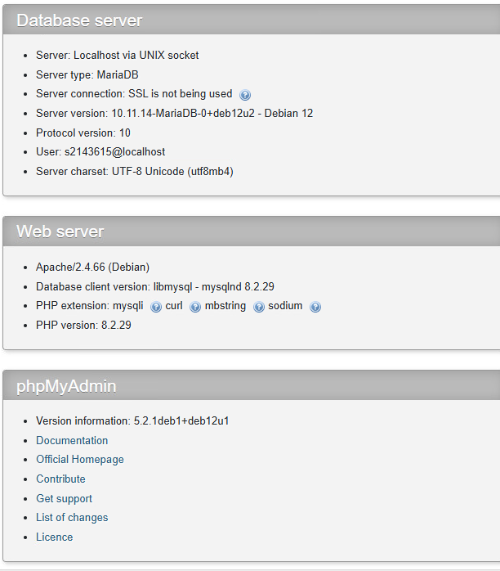

Functional Requirements
The functional requirements of the prototype are user registration and login, searching for vinyl records using various criteria, and viewing vinyl listings.
Logged users can add, edit, and delete their own vinyl advertisements as well as uploading images. An administrator must be able to manage users and listings through an administration panel.
Registered users can create an account, log in, and manage their own vinyl listings by adding, editing, and deleting records.
Users can upload images and view their listings in a personal dashboard.
Administrators can view all user accounts and listings, and are able to edit or delete inappropriate content.
Public users can browse the catalogue, search for vinyl records, and view vinyl details without logging in.

Non-Functional Requirements
The website must be easy to use and accessible to users with different levels of using technology. The interface should be responsive to work correctly on desktop and mobile devices.

Project Constraints
The project is developed as a prototype only and does not include real payment or transaction functionality. The database structure will be kept simple to support the required features only.
The focus of the project is on demonstrating core web development concepts rather than building a full commercial system. Input data will be validated on the server side to prevent invalid or malicious data from being submitted.
Prepared statements will be used in database queries to protect against SQL injection, and user passwords will be asked to be complex and to prevent from cracking.

Project Timescale
Design Document – 29th January
Stage one demonstration to tutor – Early March
Web Application Demonstration and submission – Mid March
Testing Documentation – Mid March

Target End Users
The target audience of the website is users aged 18 and over who are interested in vinyl records and music. This includes both users who wish to browse listings and those who want to advertise used vinyl records.
The website is aimed at users of all levels of computer skills. A simple navigation menu, uncomplicated website, large fonts, and images contribute to clarity and transparency.

Design Document

Site Structure

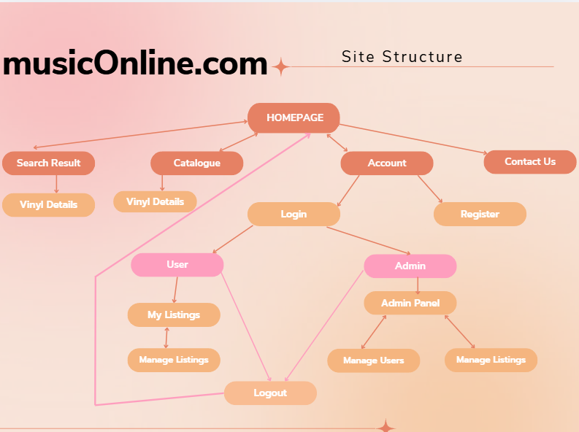

Wireframes
Home Page
Homepage displays an introduction to the website and shows the latest vinyl listings, allowing users to quickly access the catalogue and browse.
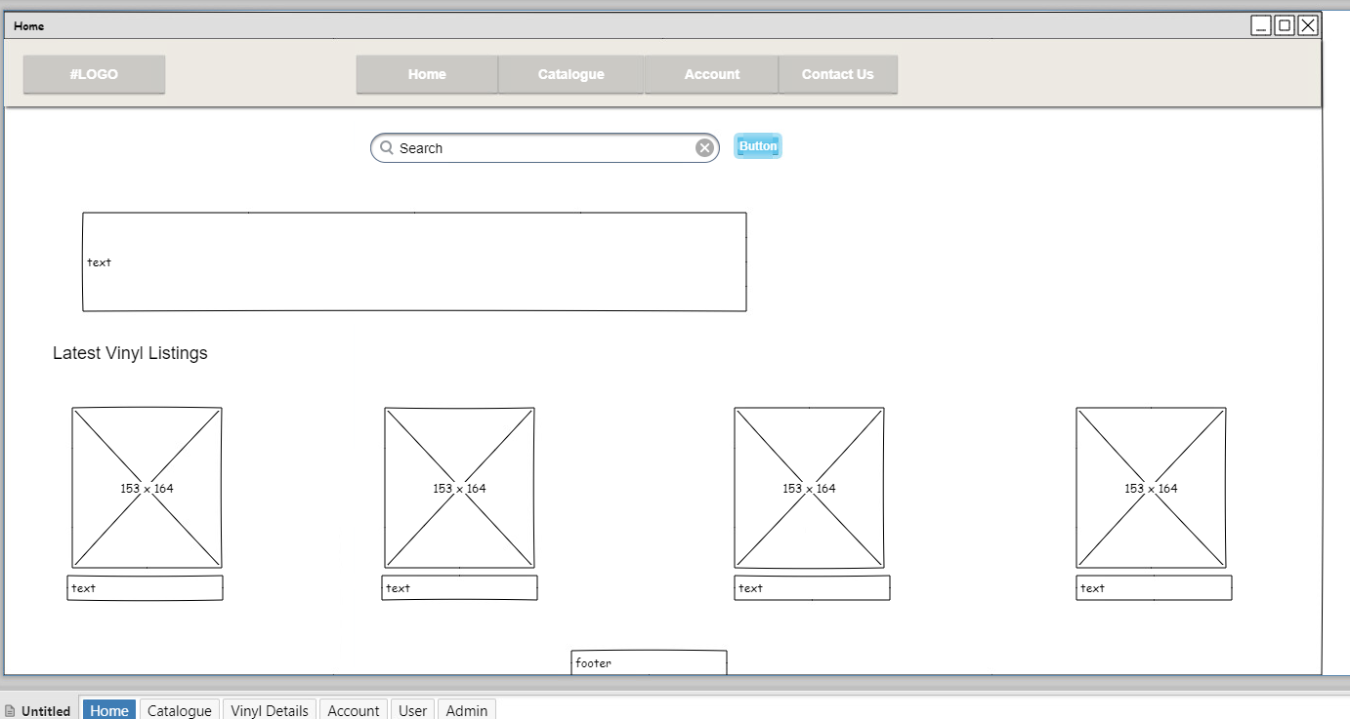

Catalogue
The catalogue page displays all available vinyl records in a table layout, allowing users to browse listings and view detailed information for each record by clicking button.
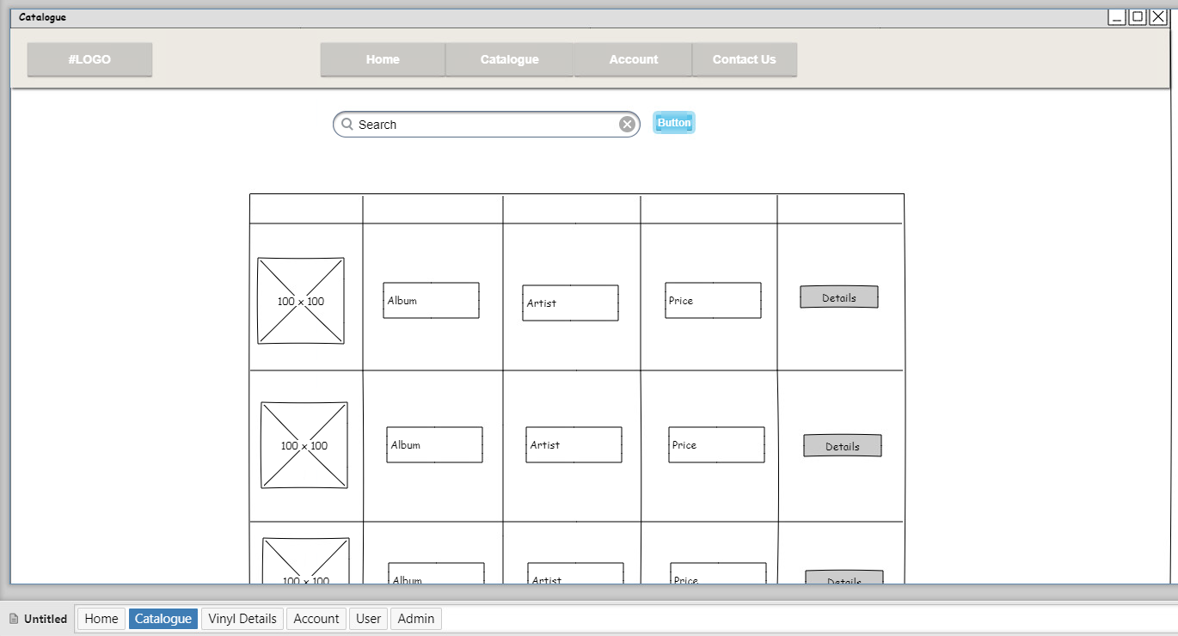
Vinyl Details
The vinyl details page displays detailed information about a selected record, including its cover image, artist, genre, condition, and price.
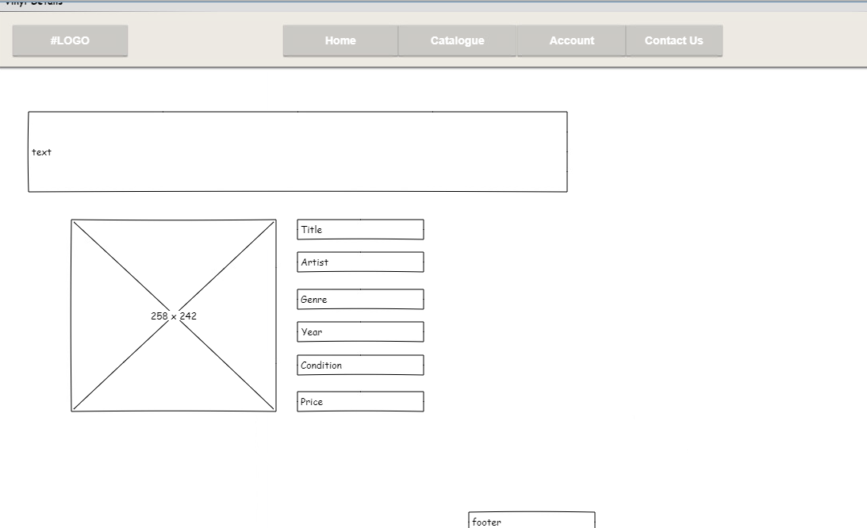

Account
The account page allows users to log in (redirecting to correct Panel) or register using simple authentication forms.
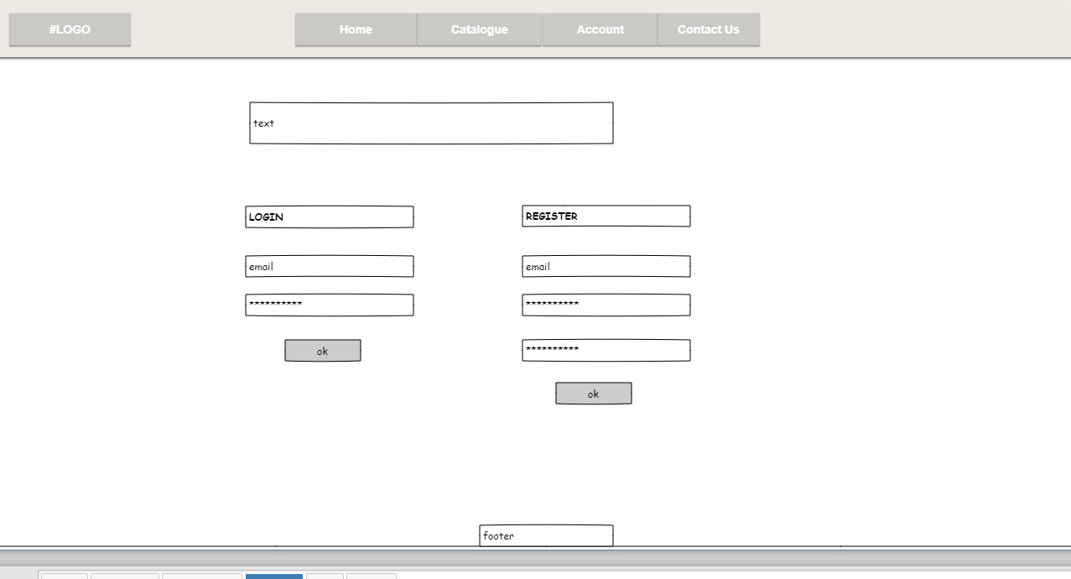

User Panel
The user panel allows logged-in users to view and manage their own vinyl listings, including adding, editing, and deleting records.
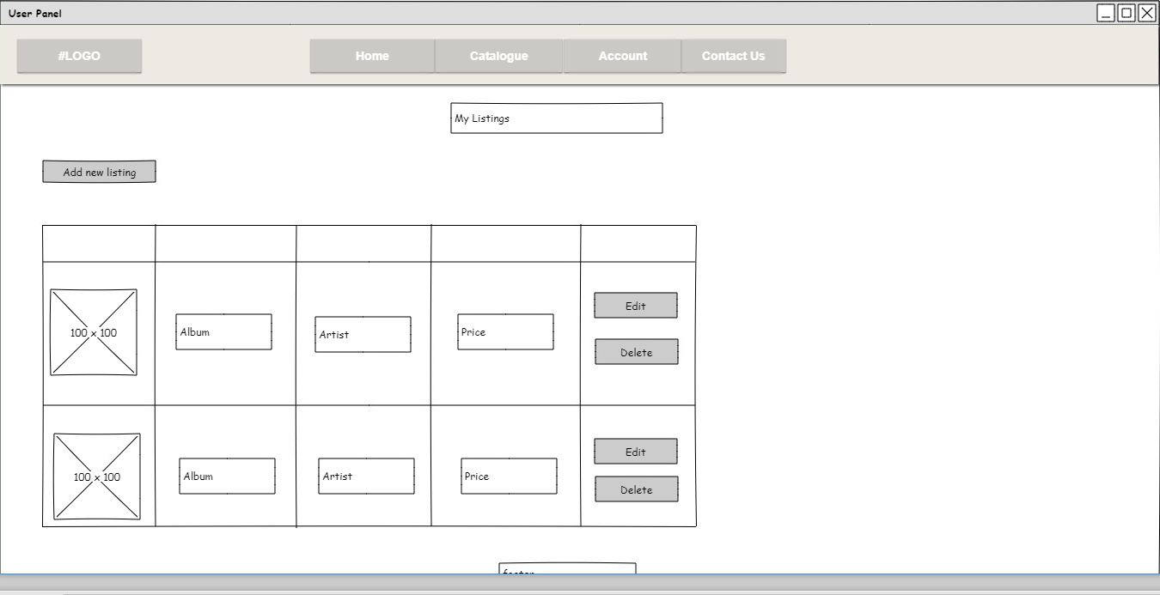

Admin Panel
The admin panel allows administrators to manage user accounts and moderate all vinyl listings on the website.
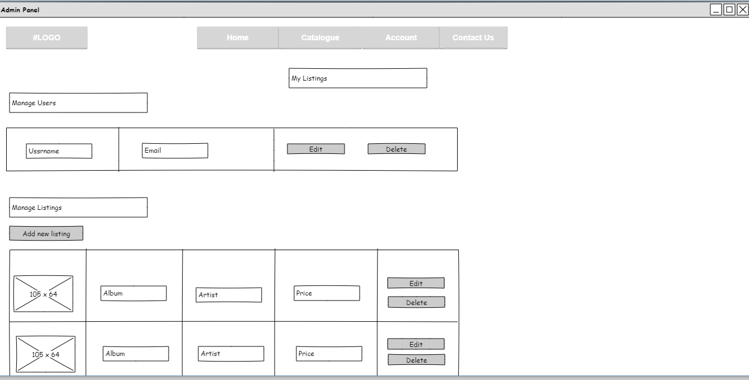

Add New / Edit Listing (form)
The add new listing page provides a form that allows users to create a new vinyl listing by entering record details and uploading an image.
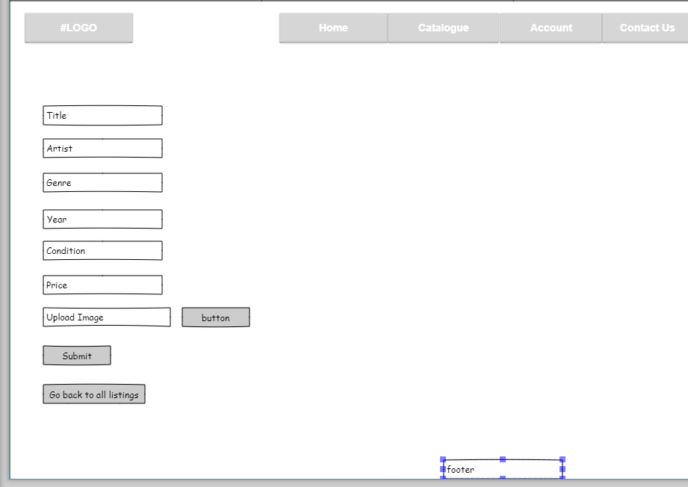

Contact Us
The contact page provides a simple form that allows users to send enquiries along with basic contact information.
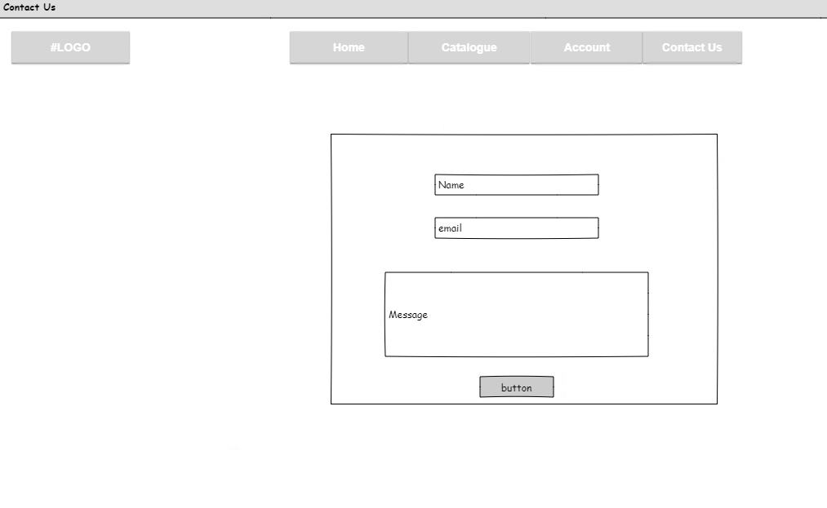
The website will be responsive, and the content will automatically collapse to fit different screen sizes. This is what the pages will look like. Example showed on Home Page, User Panel, Account, Catalogue, Vinyl Details, Admin, Add new/edit listing page,
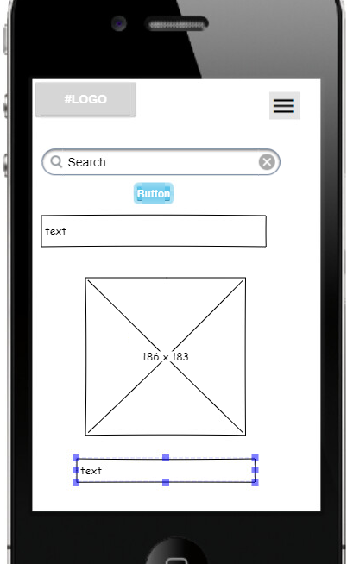 | 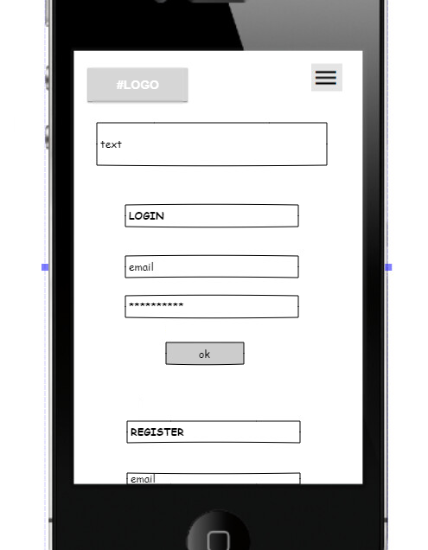 | 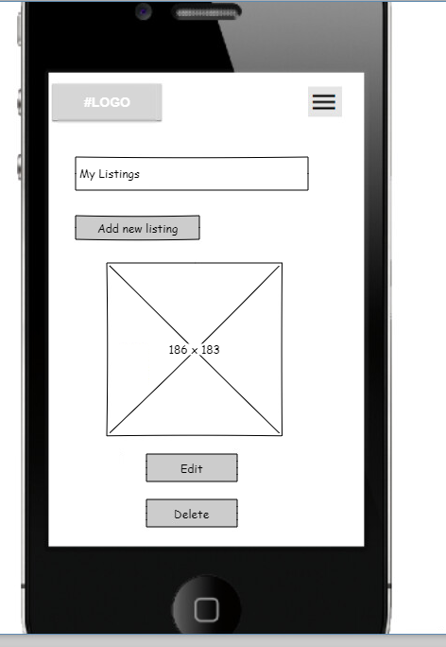
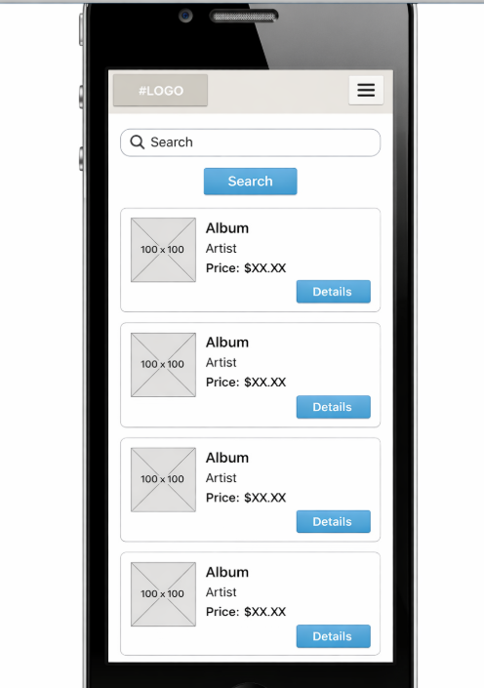 | 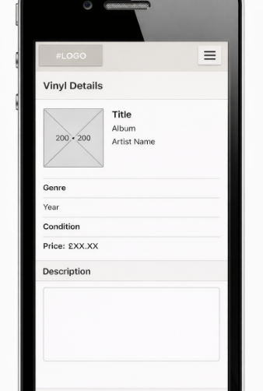 | 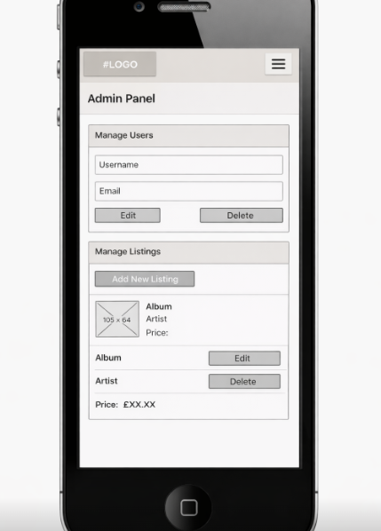
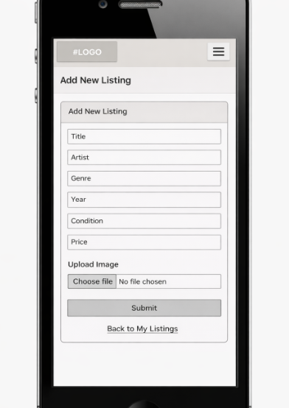 | 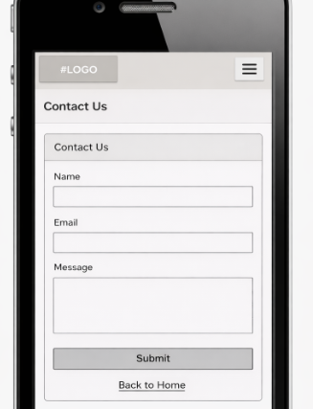

Page content summary

- The home page: features a search bar, an overview of the website, the most recent vinyl listings, and a link to the complete catalogue.
- The catalogue page: features a table view of all the vinyl records that are available, along with a "Details" button for each record.

- Vinyl Details Page: Provides comprehensive details about a single chosen vinyl record, such as image, title, artist, genre, condition, year, and cost.

- Account Page (Login/Register): Using straightforward forms, users can log in or register for a new account.

- Users who are logged in can view and manage their own listings (add, edit, delete) using the User Panel (My Listings).

- Add/Edit Listing Form: Edit uses the same form as Add Listing with pre-filled data.

- The administration panel is available only to users with administrator privileges.
The page allows the administrator to view all registered users and all vinyl listings stored in the system.
Administrators can edit or delete user accounts and vinyl listings using simple action buttons.
When deleting a user account, the administrator is informed that all vinyl listings associated with that account will also be removed.
A confirmation step is included before deletion to prevent accidental data loss and to maintain database integrity..

- Contact Us Page: This page includes a contact form for user enquiries.

Data Source Design – data dictionary
Database s2143615_musicOnline
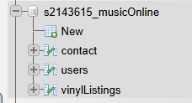

Contact
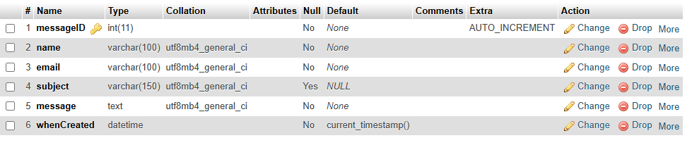

Users
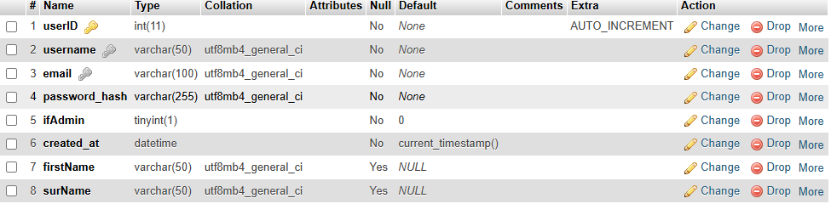

vinylListings
